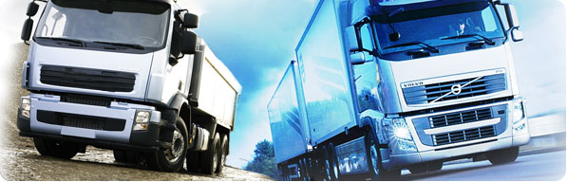


Fleet Performance Management Frameworks for Business Improvement

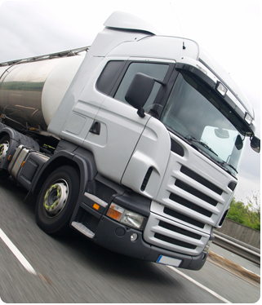
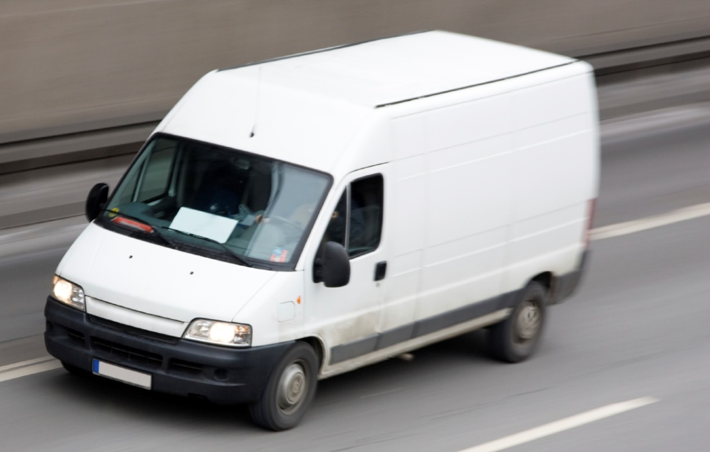

Reading the Runes for 2013

It is no surprise that the latest economic forecasts predict familiar challenges for the road haulage and distribution in 2013, similar to those faced since the credit crunch of 2008. Most businesses are basing their performance forecasts allowing for a relatively flat growth rate and continued subdued consumer spending, and expect little relief on fuel costs or reduction in operational overheads.

For the UK based commercial fleet owner, the operational concerns continue to be centred around the high fuel price, congested highways, the high cost of adherence to regulations and compliance to the SLA's of an ever more demanding customer that will impose excessive fines for relatively minor transgressions.

Further the lack of availability of investment funding and lack of bank assistance forces businesses to protect existing cash reserves and profit margins. Businesses have become highly risk averse, and lack of capital and market uncertainty has confined them to protect what they have.

Management focus is on three business imperatives:

  - Ensuring that return on vehicle assets is optimised by raising tonnes per kilometre, incre asing the number of deliveries and lengthening asset lifecycles.

  - Taking every opportunity to increase revenues and reduce costs to achieve higher margins, and profitability, thereby generating cash headroom.

  - Ensure that profitable contracts are retained by maintaining SLAs and raising the standards of customer service.

Does Technology Hold the Key?

As always, correctly applied to the areas that will generate the quickest and best return, automation will increase potential business capacity by using the current asset base and without taking on more staff.

Providers are only too aware of the needs of their customers to preserve CAPEX and have aligned their business models with the investment and operational requirements of the sector they serve, and have made life easier for financiers, managers and users by:

- Switching from capital purchase to rental models, that generate savings in excess of cost outlay on a month by month basis, and that build-in all lifetime cost (e.g. upgrades, maintenance operations etc.)

- Offering services that can be flexed as the demands of the business change over time , by building on the existing platforms rather than replacing them.

- Delivering high value, advanced, easy to use systems (across PDAs, portables, tablets, and smartphones) and granular management reporting technologies that quickly highlight areas of potential cost leakage.

Overall, advanced technologies now negate the need for CAPEX, while start-up costs are kept low. Impact on cash flow is quickly positive (as technology should more than pay for itself post-installation). Additionally modern platforms allow room to upgrade in order to further improve margins over time, so that no legacy investment is wasted or written off.

Building a Cost Efficient Model to Drive Improvement

To begin with most hauliers already have some form of information technology, at least running some form of tracking technology. In this paper we discuss the pros and cons of these and other technologies available, beginning with the adoption of simple tracking technology through to the complete integration of the back-office scheduling, accounting and reporting systems.

We also examine the technology available to resolve the challenges presented by the current business environment, and the technology options available to key industry sectors that will help them not only improve overall fleet performance but also present opportunity for further improvement across the business.

Fast Implementation and Fast Results - Helping Businesses Quickly Operate at Their Optimal Limits

It is important to choose a supplier with a track record of providing reliable, functional and cost effective systems and that have a reputation for longevity and reliability. Suppliers should provide a range of standardised and bespoke applications that suit your particular industry.

By adopting systems that are fast to implement, intuitive and productive and basing costs on rental models, operational systems can be deployed quickly and overhead can be reduced almost immediately allowing businesses to build cash reserves, particularly as outlay is more than off-set against month by month returns generated by their investment.

Such models can generate a higher (and earlier) return on investment. This is important as it allows owners of smaller fleets to have access to better and cheaper technologies that improve competitive positioning.

Engaging with Your Supplier – Steps to Formulating a Solution

- Discuss and Resolve How Existing Technology Can be Improved

It is important to discuss all the key aspects that can help improve business performance and establish the most cost effective and suitable vehicle management technology that will address your key requirements now and in the future. From this an analysis of lifetime costs against the savings that will be made should be presented by your supplier.

- Formulate a Longer Term Plan (Road Map)

The supplier should discuss the various types of technology available and how each component can help streamline your business. From this a road map for continued improvement can be presented.

- Technical Analysis

Once your requirement has been established technicians can analyse exactly what data needs to be collected, analysed, and reported, and build a solution that is fast, intuitive and user friendly.

- Seek Best Hardware Advice

Selection of the best hardware system will take account of durability, capital and maintenance costs, the threat of theft (consumer devices are more prone to be stolen), reliability and of course, usability.

For those with existing systems there are several levels of upgrade that can be provided.

- Trial

As part of the contractual agreement a trial should be arranged to confirm:

- Speed and reliability of communications and data transmission and reception.
- Functionality and usability of all in-cab hardware and devices (e.g. driver screen, mobile, tablet etc.)
- Accuracy of reporting formats and analysis (particularly Identification of areas for improvement).
- Effectiveness and performance of all points of integration with other systems.

Available System Types

Level 1 – Basic Track & Trace Systems

Useful – But Limited in Functionality and Capability to Reduce Costs

Tracking technology is widely used and is based on a simple transmission only, on board device (you can even use a mobile phone) that can be tracked using GPS (Global Positioning Service satellite). Positions can usually be viewed on screens at head office.

Often driver/head office communication is by mobile phone and route planning is by standard consumable SatNav input by the driver.

These systems are useful for schedulers who wish to use tablets, PC screens, or large wall-mounted LCD screens to identify precise positioning. However strategic business improvement is limited, particularly if paper and human intervention (and therefore error) is still in evidence.

In isolation, tracking systems do not monitor fuel use or pinpoint areas of poor driver behaviour (e.g. cannot detect unnecessary idling), or accurately anticipate arrival times. The status of the vehicle or its load remains unknown. Consequently manual status reports are frequently required, and customers often need to call the contractor to receive an update, who in turn may have to place a call with the driver.

This non automation is often coupled by a manual scheduling and management reporting process that generates unnecessary paperwork and superfluous driver conversations. These factors drive up costs, leaves potential for error and customer dissatisfaction, all of which can be largely avoided. Also identification of other potential causes of cost leakage is not identified or reported.

Theses systems have been largely financed by the reduction in insurance premiums estimated at 5%.

Level 2 - Adopting Fuel Use and Driver Behaviour & Tachograph Reporting

Minor Upgrade Brings 5-20% in Fuel Cost Savings

An upgrade can be provided by installing a small on-board unit that collates and transmits real time data gathered from the engine and internal systems. Touchstar's systems generate a red, amber, green, easy to read report that highlights fuel use and cost as well as other areas of potential cost leakage, so that appropriate action can be taken.

Advanced versions also correlate weight and road conditions for higher accuracy and can also monitor tyre pressures and axle weights as well as perform a vehicle systems test on start-up to ensure everything is in order for the days' work. Touchstar's systems can also gather and analyse tachograph readings for Working Hours compliance (dependant on tachograph type).

However paper and human intervention (and therefore error) is still in evidence, anticipated arrival times are estimated and there is no load status monitoring, or two- way driver communication (except by Mobile phone). We can augment these systems and provide a platform for continuous improvement which can be easily adopted, allowing the business to pursue a sustainable plan for continued cost reduction and performance improvement.

Typically the cost of fuel for a diesel truck, with a 70k annual mileage at 12 mpg, is approx £30,000, savings can be anticipated at £1500 to £6000 per vehicle. Therefore fuel savings will more than finance the initial deployment of the system while multiple savings should accumulate thereafter.

Further, better driving reduces the level of wear and tear and lengthens asset lifecycles resulting in considerable savings in vehicle acquisition and service costs.

Level 3 Streamlining Driver Communication & On Board Devices

A First Important Step That Can Substantially Reduce Costs Across the Business

It is important to eliminate the devices that can clutter the cab (separate mobile phone, SATNAV, printer, tablet, PDA etc. can largely be eliminated), reducing capital and rental costs overall, avoiding operator confusion and minimising driver distractions.

These can be replaced by a single industry strength on-board touch sensitive computer screen and printer device that will carry out all functions, minimising the risk and cost of theft (and cab damage) associated with consumer devices, reducing accidental breakage costs, and providing a platform to accommodate further upgrades such as automated scheduling and route planning, and on-board plant or load monitoring etc.

The software is upgradeable (so there is no need to replace hardware over time) and standardised to avoid version management issues.

Level 4 –Advanced Monitoring of Load and On-Board Plant and Machinery (Inc. Integrated PDA use)

Generate Substantial Commercial Benefits – via Bespoke Sector-Specific Solutions

Sector specific systems can monitor load condition (e.g. temperature audit trail for pharmaceuticals) and list on board inventory status, calculate pick-up weight information (e.g. for waste disposal), take remote meter readings (e.g. for fuel delivery tankers), produce delivery notes or certificates (for multiple uses), monitor plant use (e.g. for construction), monitor traffic count and produce audit trail of activity, timestamp cone and traffic light deployment for health and safety measures (for road maintenance), film and track job progress (any outside task) photograph/video incidents or on-site problems and audit remote assets (e.g. utilities).

Level 5 - Integrate Back Office Systems

Full Integration Across the Business – Displays the Highest Increase in Cost Savings and Improvement in Overall Competitive Positioning

New applications can be integrated into this structure, and the data derived from mobile devices can also be integrated with various back office systems. These include scheduling and resource management systems (such as transport and fleet management systems), invoicing systems, management accounting and costing systems, and comprehensive management reporting systems.

For example users can combine in-cab data and add a scheduling system to streamline back-office booking functionality, optimising the best use of the vehicle fleet while minimising paperwork and human error. This also provides capability to increase income by adding additional drops and pick-ups while vehicles are on the road, and substitute alternative vehicles to complete job requests.

Integrating with invoicing systems allows them to be despatched as soon as goods are delivered. This continued accuracy minimises invoice disputes and shortens cash recovery time.

Management costing systems can cost ‘job by job’ and therefore can identify and filter out low profit contracts, whilst automating management reports to save time and specifically highlight areas of cost leakage.

Typical, Integrated, Paperless Vehicle Management Solution
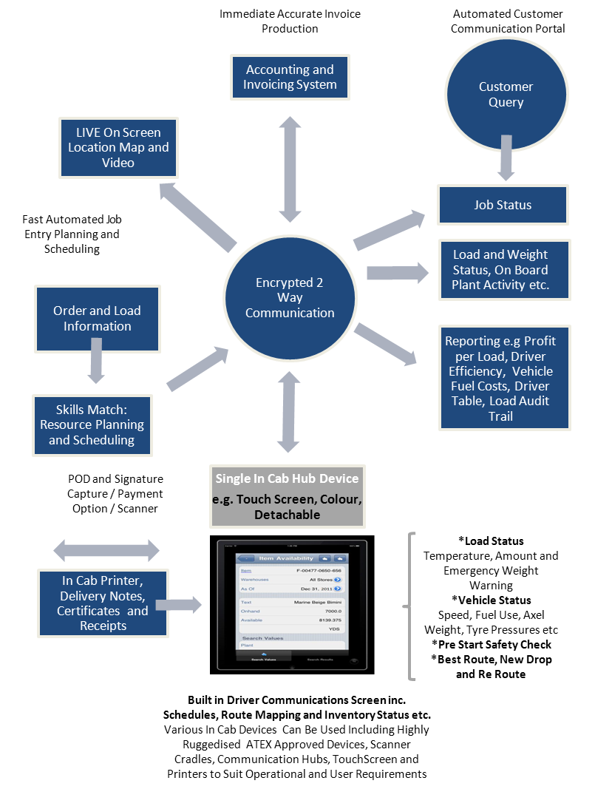

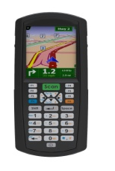

Sector Examples

Use of Telematics to Resolve Critical Business Issues Within Key Sectors

The first “General Transport” is applicable to all owners of commercial vehicles, while additional sections address the key needs of specific listed sectors.

Industry Sector | Key Drivers | How Touchstar Can Address the Issue
General Transport & Haulage (Point to Point).  Applicable to all sectors | Reduce Fuel Cost  Lengthen Vehicle Lifecycle  Implementing Health and Safety Policy to Protect All Stakeholders  Use most cost effective route  Ensuring Vehicles are Operational  Working Hours Compliance | Touchstar's comprehensive and accurate fuel and driver behaviour reporting – ensures best economical use of vehicle, and encourages better driving standards.  Drivers can be offered retraining and incentives to improve performance  Touchstar's streamlined in-cab systems eliminates mobile phone distractions by communicating by text. The systems also incorporate SatNav capability into single cab device.  The system automatically directs the driver to the next pick-up or drop off point without driver needing to input the destination.  Touchstar's systems incorporate a vehicle “self test” of all critical components at start up and while the ignition is switched on.  Touchstar's telematics automates the integration of tachograph data with real-time management reporting to identify status and provide early warning of potential non-compliance.
General Transport  Multi-Pick Up and Delivery | As above and also  Increase fleet capacity and potential to increase income  Minimise “Cost per Drop”  Monitoring Status of Inventory  Improve cash flow & avoid invoice disputes. | The integration of a recommended partner scheduling systems will allow head office to book extra visits while vehicle is in transit.  This system will allocate the “best choice” vehicle. This will optimise fleet use, minimise costs, manual paperwork and unnecessary communication (eliminates mobile phone calls with head office).  Implementation of Touchstar's on-board inventory control systems can monitor load condition and inventory quantity.  The system will automatically produce a real-time invoice by signalling completion details to the head office system immediately on delivery or job closure.
Transport  Heavy | Monitoring Load Capacity | Touchstar's systems will monitor axle weights to determine status and alert the driver and dispatcher should a breach occur.
Transport  (Tanker Fleets ) | Ensuring Vehicles are Safe and Operational | Tanker fleets are particularly susceptible when carrying inflammable loads.  Use Touchstar ATEX devices to eliminate possibility of spark ignition for inflammable loads and take account of ADR regulations.
Plant and Vehicle Hire | Lengthen asset lifecycle  Maximise Availability | Touchstar's (basic tracker) systems can be used for all hire of vehicles and expensive plant to reveal vehicle whereabouts and potential driving abuse which will increase service costs, increase vehicle lifecycle costs and avoid unnecessary accidents.  Engineering resources can be optimised by using Touchstar's partners scheduling systems to locate and schedule repair locations. Touchstar can also provide mobile systems that can access on-line repair manuals and parts order facilities to speed repair cycle.  Touchstar's Tracker systems can identify plant not-in-use and its whereabouts.
Mobile Engineers | Minimise Cost of Visit | Engineering resources can be optimised by using authorised partner scheduling systems to locate and schedule repair locations. Touchstar can also provide mobile systems that can access on-line repair manuals and parts order facilities to speed repair cycle.
Construction  General | Avoid costs associated with over loading. | Touchstar Telematics systems can monitor and remotely identify breaches of axle weigh limits.
Construction  Heavy vehicles and Tipper | Reduce cost of fuel and lengthen lifecycle. | Advanced telematics is particularly appropriate for high cost vehicles such as tippers that also operate under harsh conditions. Touchstar is renowned for its manufacture of ruggedised systems.
On Board/Off Board Devices and Components. | Reduce maintenance costs.  Pinpoint failure points.  Speed cash collection. | Touchstar can monitor and report the activity of any remote device (e.g. meters, valves, alert trigger thresholds) and can confirm operational status, pinpoint areas of failure and (if metered) transmit usage statistics for invoicing.
Local Authorities | Maintain service levels | Local authorities provide a diverse range of services, from lawn mowing and community transport to waste disposal and road maintenance. Touchstar's expertise in delivering a broad range of expertise in scheduling, remote vehicle management, and workforce monitoring make us an ideal technology partner.
Waste Disposal | Invoice by weight.  Avoid error  Reduce the cost of processing  Sort and weigh waste and designate recyclable by type. | Touchstar's systems can weigh incoming waste per collection basis and transmit invoice details to head office for fast and error free despatch.  In-cab systems can report the status of loads expected for recycling or landfill.
Road Repair and Maintenance | Schedule and locate quickly.  Observe health and safety criteria  Record and provide audit trail | Operating in live traffic, road repair teams need to observe the health and safety requirements. These may be subject to audit, and in the case of emergency call-outs may be subject to strict SLA terms.  Touchstar can provide systems that track the progress of all work and traffic activity, timestamp critical device deployments, remotely monitor traffic flows and also report job progress.

For Further Information

We will be pleased to evaluate your requirements and submit our best advice and recommendations on any aspect of remote vehicle management. Please do not hesitate to contact Karen Taylor (E:Karen.taylor@touchstar.co.uk) and visit our websites www.touchstar.co.uk and www.advanced-telematics.com.

Touchstar Technologies Ltd are part of the Belgravium Technologies Group Plc, other group members service the mobile computing requirements of the global Airline, Rail, Fuel and Logistics sectors.

Touchstar Technologies Ltd
7 Commerce Way
Trafford Park
Manchester
M17 1HW
Tel: 44 (0)161 8745050
www.touchstar.co.uk

.

